ECE 3355 – ELECTRONICS
HOMEWORK #11

Extra Problems E11.1, E11.2, E11.3, E11.4, E11.5: These problems are shown below and on the next pages.

E11.1. The schematic symbol for a Giambulator is shown in Figure 1. Two characteristic curves for this device are shown in Figure 2 and Figure 3. Find a model that could be used to predict the behavior of a Giambulator that has been biased into Region 1, for small signals. Draw the model, labeling all components with their numerical values, and labeling terminals a, b, and c.
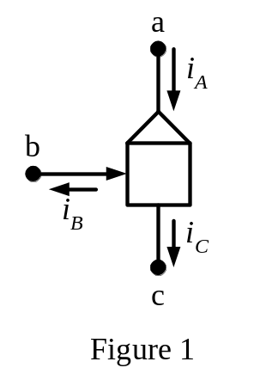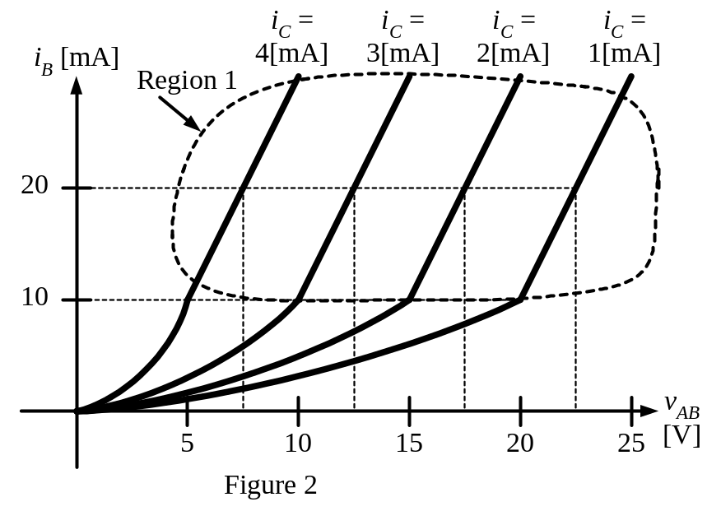
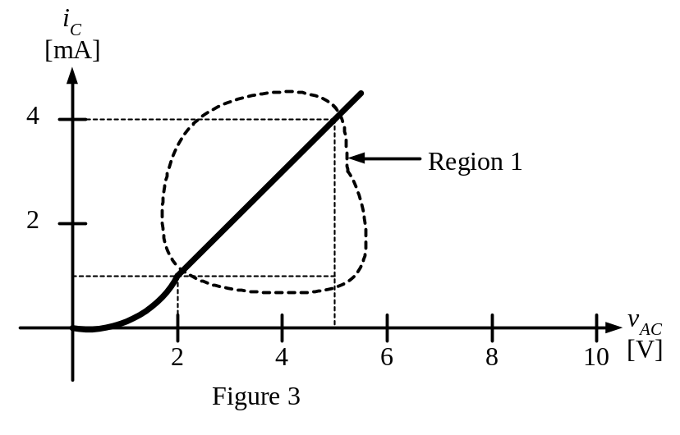
Problem E11.2 A device called a Davistor has three terminals called a, b, and c. The device has the schematic symbol shown in Figure 1. Reference polarities for the currents in this device are shown in Figure 1. The device obeys the characteristic curves shown in Figures 2 and 3. Find a model that could be used for this device for signals, valid for when the device has been biased in to the region marked the “linear region”. Explain your answer using complete sentences.
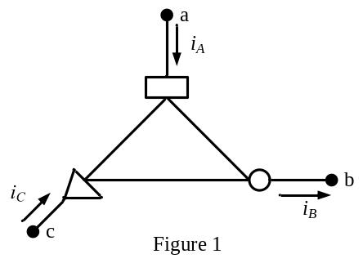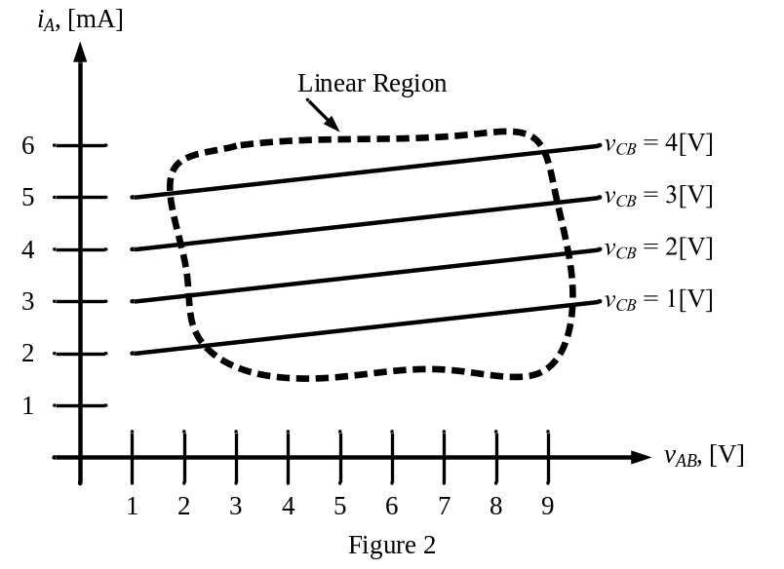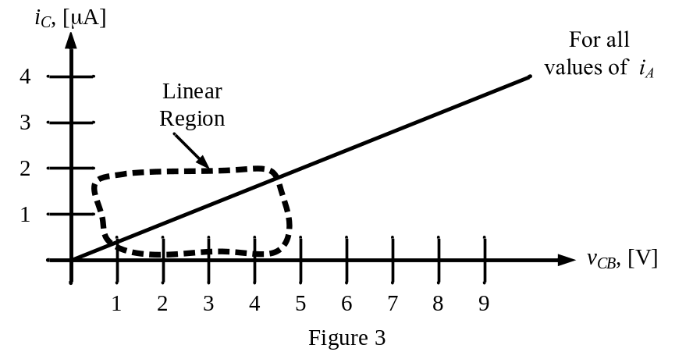
E11.3 A new device, known as a Barcelonor, has the schematic symbol as shown in Figure 1. Using the polarities defined in this figure, a characteristic curve for this device is plotted in Figure 2.
Two identical versions of this Barcelonor are inserted in the circuit shown in Figure 3. Find V_{X}.
Show your work. State your guesses, and test them explicitly.
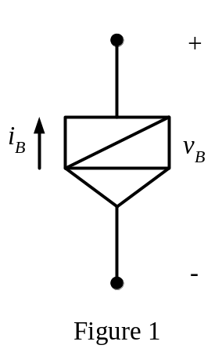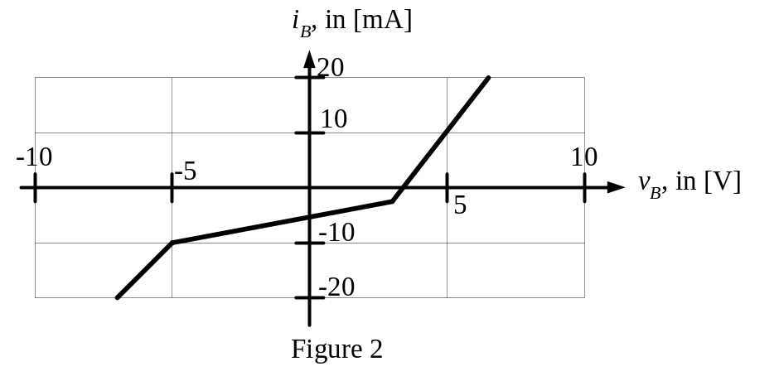
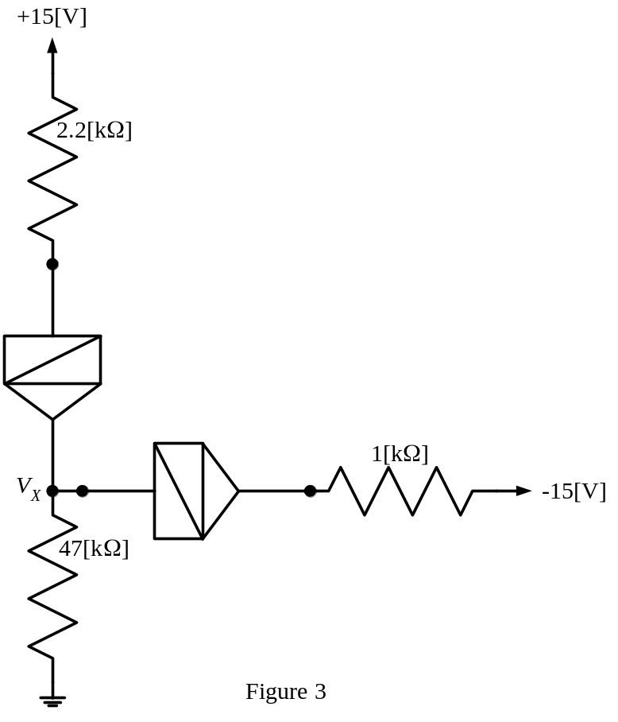

E11.4 A piecewise-linear diode model can be used to model a diode that has been connected to a device. The device is linear. The diode can be modeled using a piecewise-linear model with V_{f} = 0.7[V], r_{d} = 100[Ω], and I_{s} = 1[mA].
- Assume that the device has a Thévenin equivalent resistance that is positive. How many different solutions for the diode current can there be in this case?
- Assume that the device has a Thévenin equivalent resistance that is negative. How many different solutions for the diode current can there be in this case?
Explain your answers to both parts of the problem, using diagrams, plots, and complete sentences.

E11.5 The characteristic curve for a device known as a Shadractor is shown in Figure 1. The definitions for the polarities for the current and voltage are given in Figure 2.
- Find a circuit model that would be appropriate for use in the range
7[mA] < i_{A} < 10[mA]. Draw the model, labeling terminals b and c.
- Find a model that would be appropriate for signals, for I_{A} = -8[mA]. Draw the model, labeling terminals b and c.

